Name: Hamzah Ahmed

Reg No: 4164-FBAS/BSSE/F21 (A)  
  
  
Github Repository URL: <https://github.com/Hamzah712/Login_Page-using-java-AWT>

Commands used

1. Git init  
   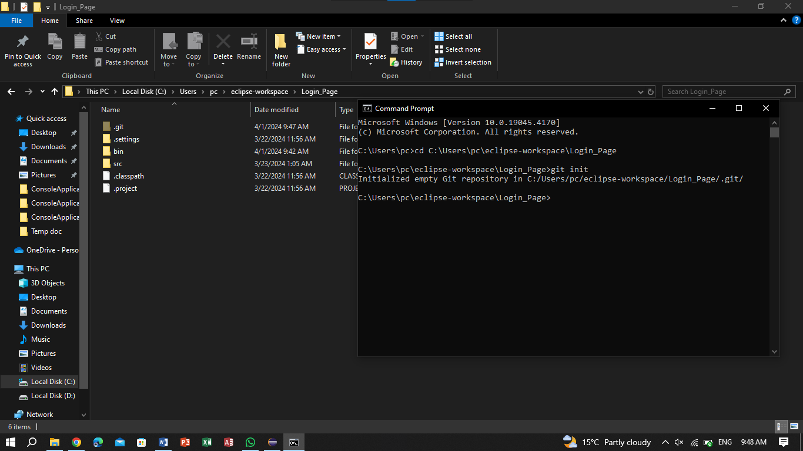
2. Git status

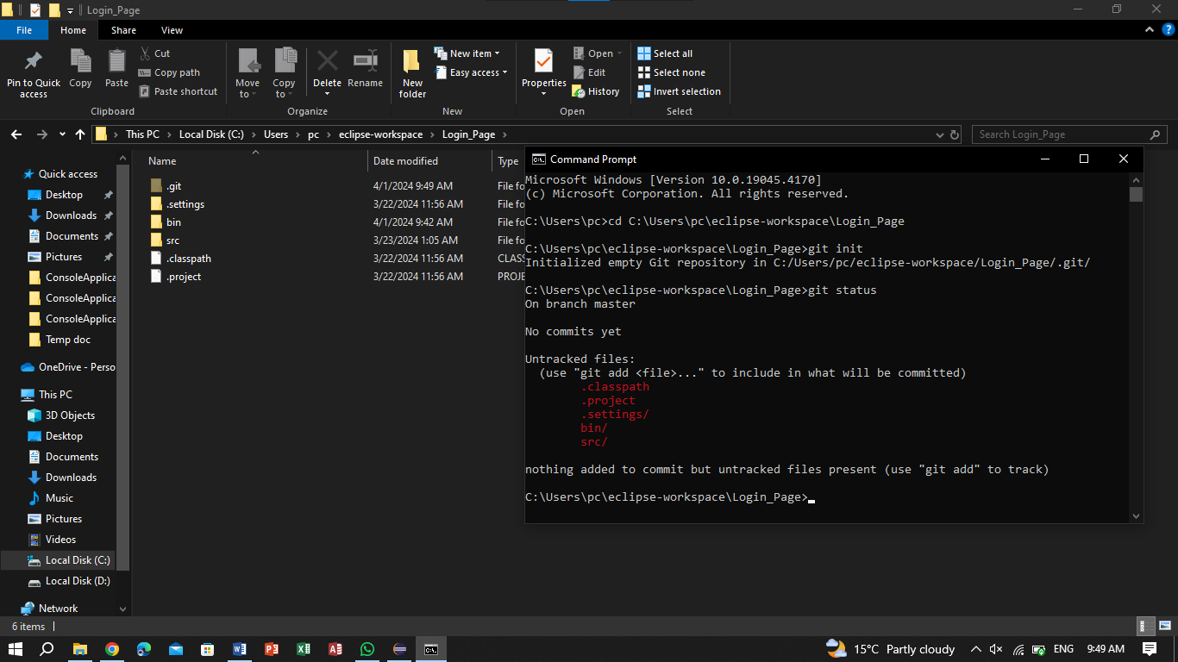

1. Git add . & git status

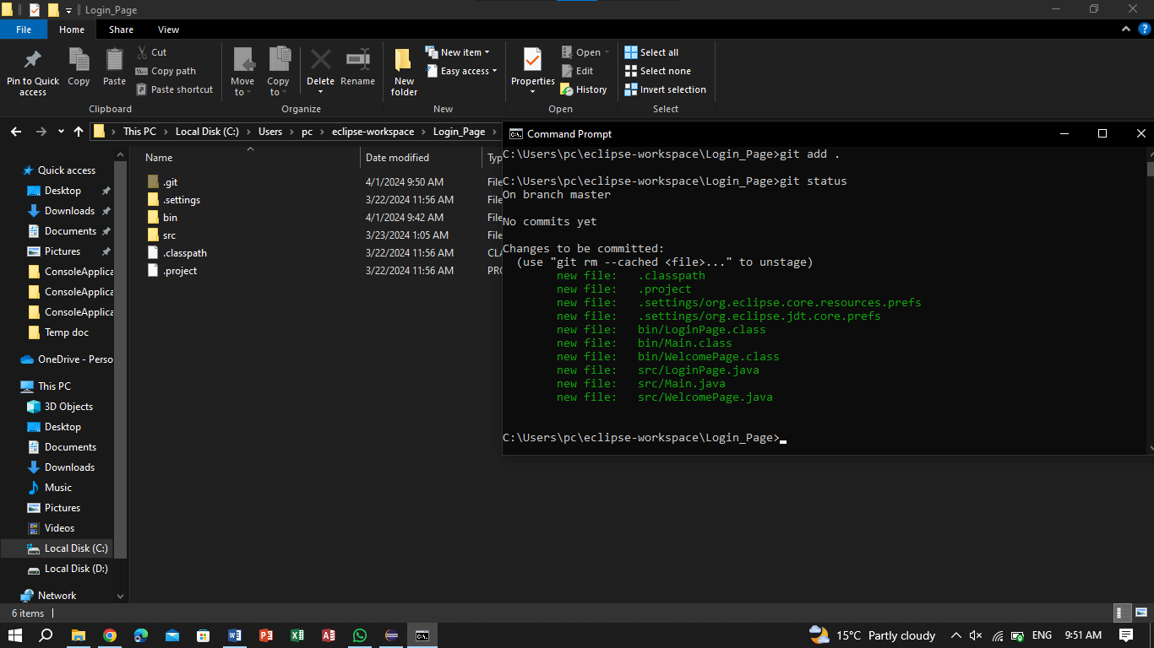

1. ADD README.md to local repo

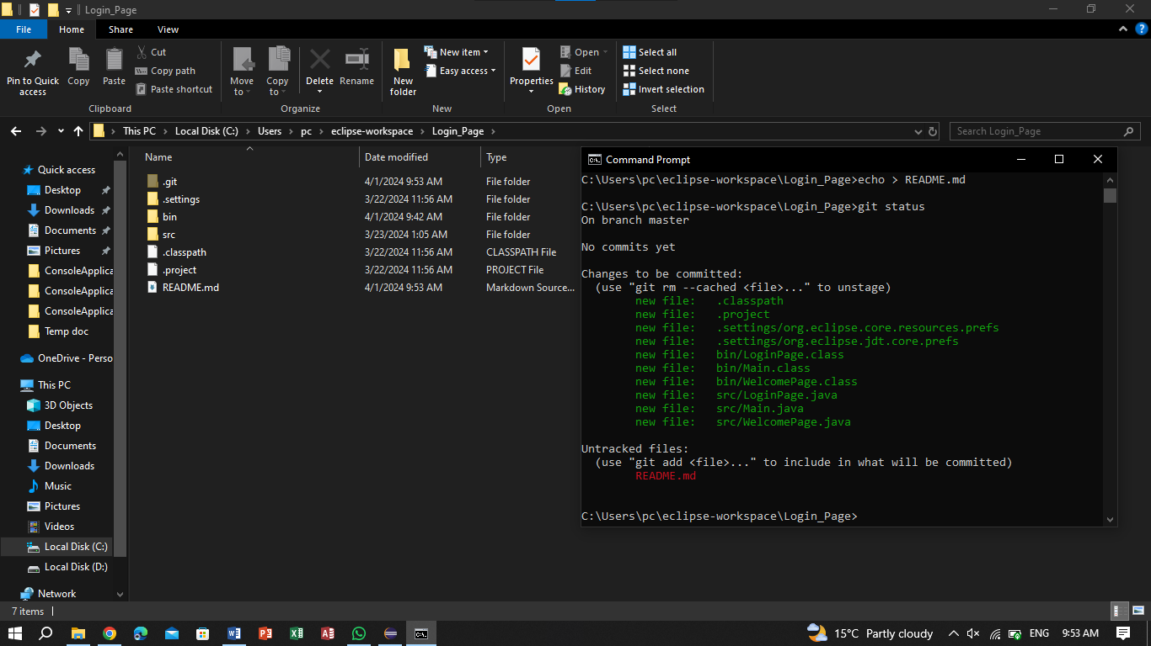

1. Add read me and commit changes

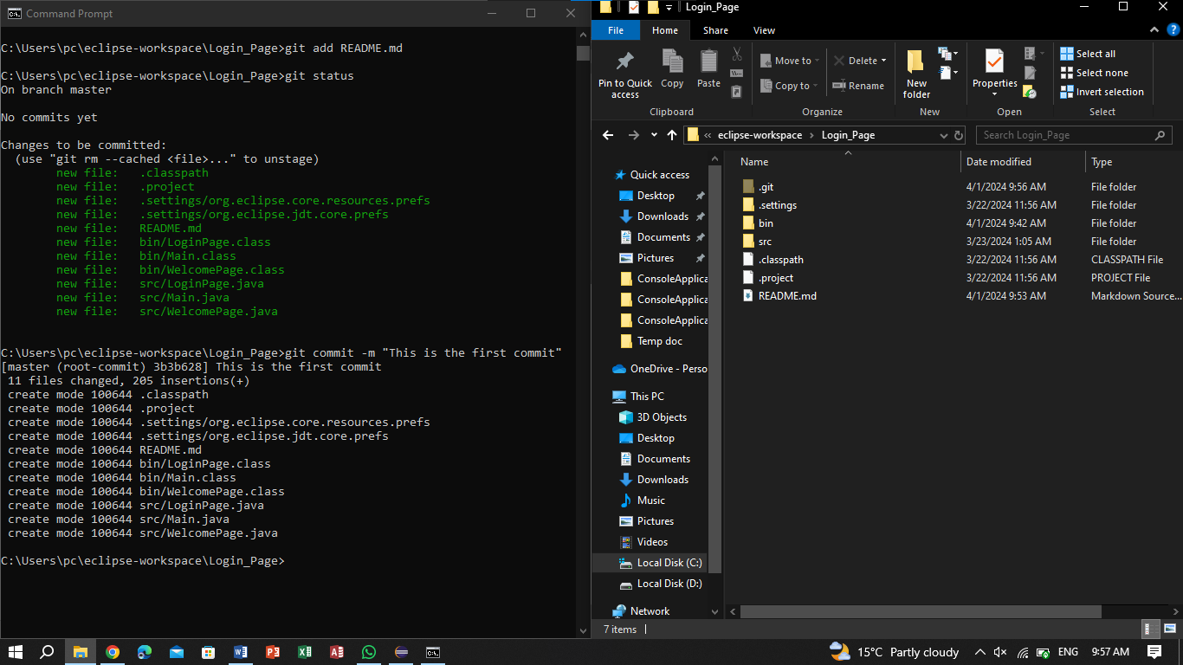

1. Check the current branch and add a new branch called new-feature1

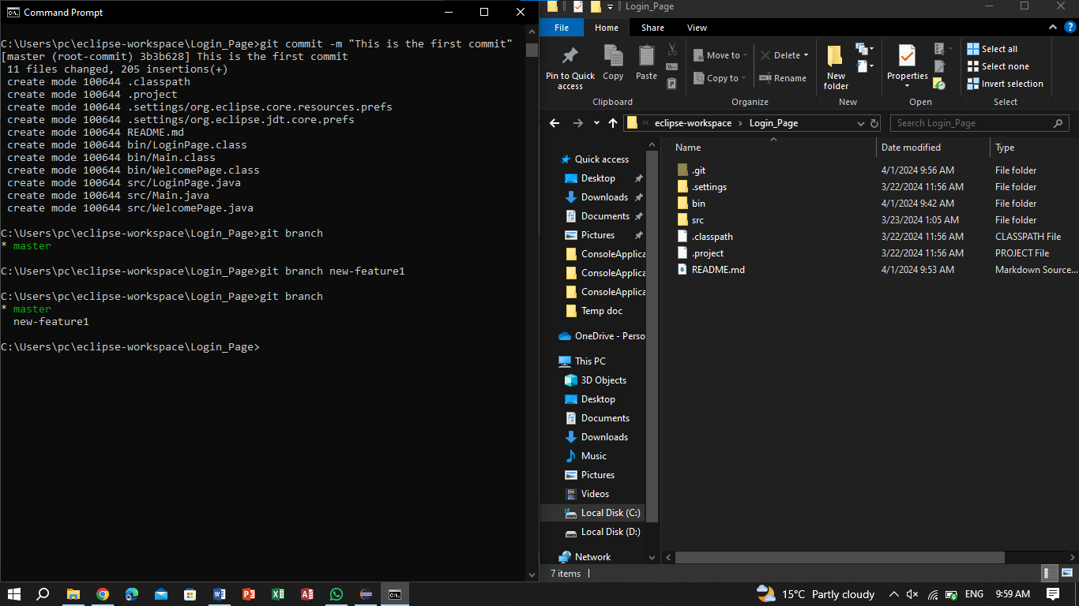

1. Switch to new-feature1 branch and git status

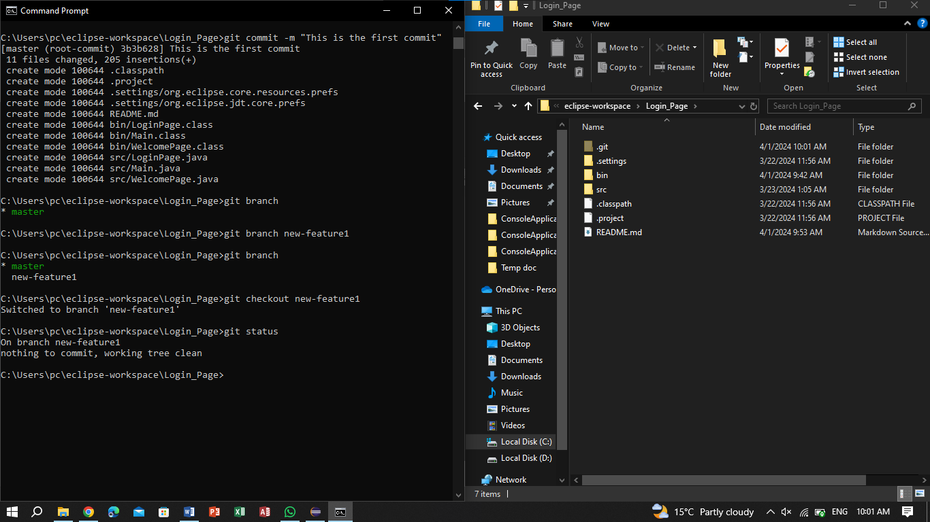

1. Changed few lines in project in branch new-feature1

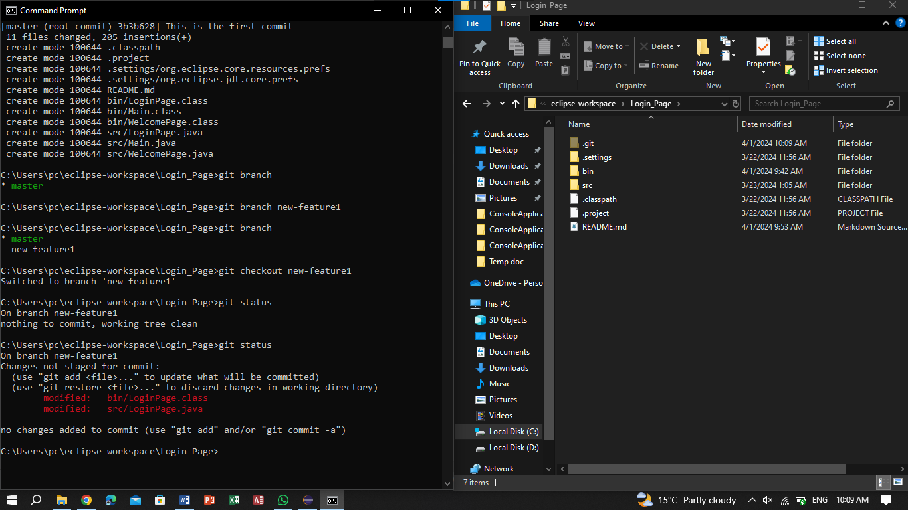

1. Added the changes then commit

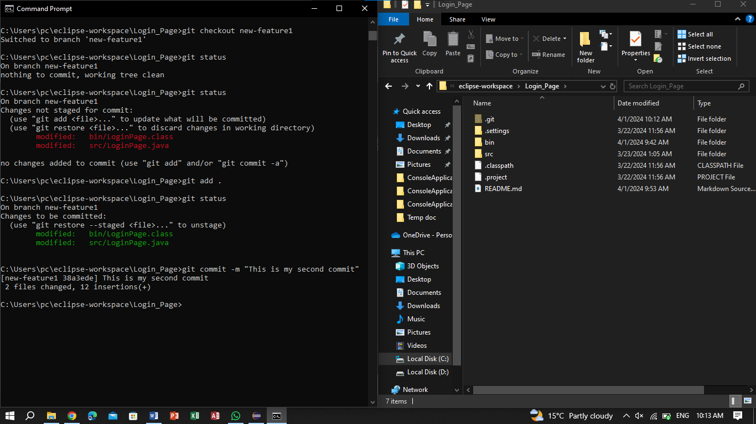

1. Created a new branch new-feature1.5

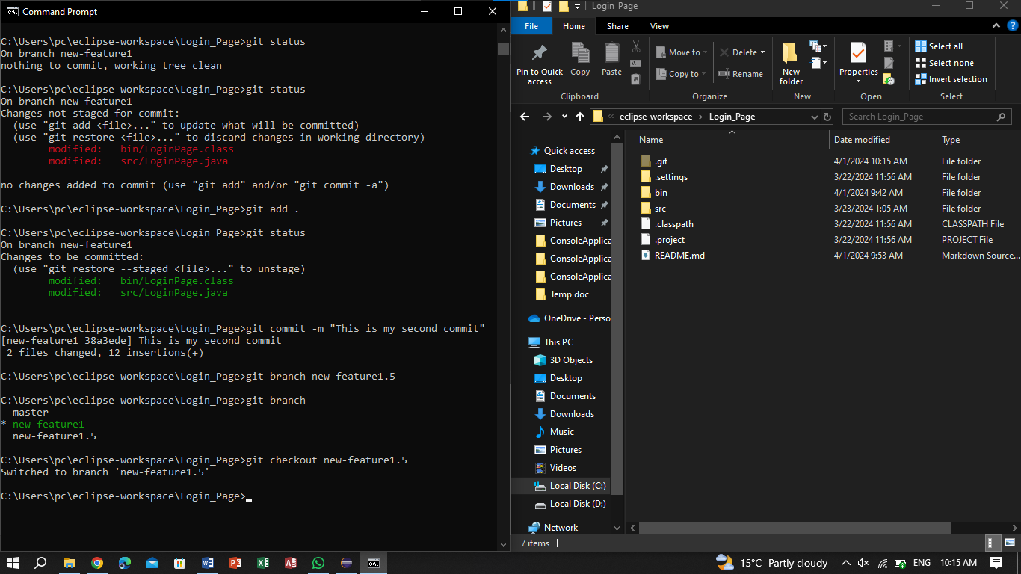

1. Made changes in new-feature1.5 then added them

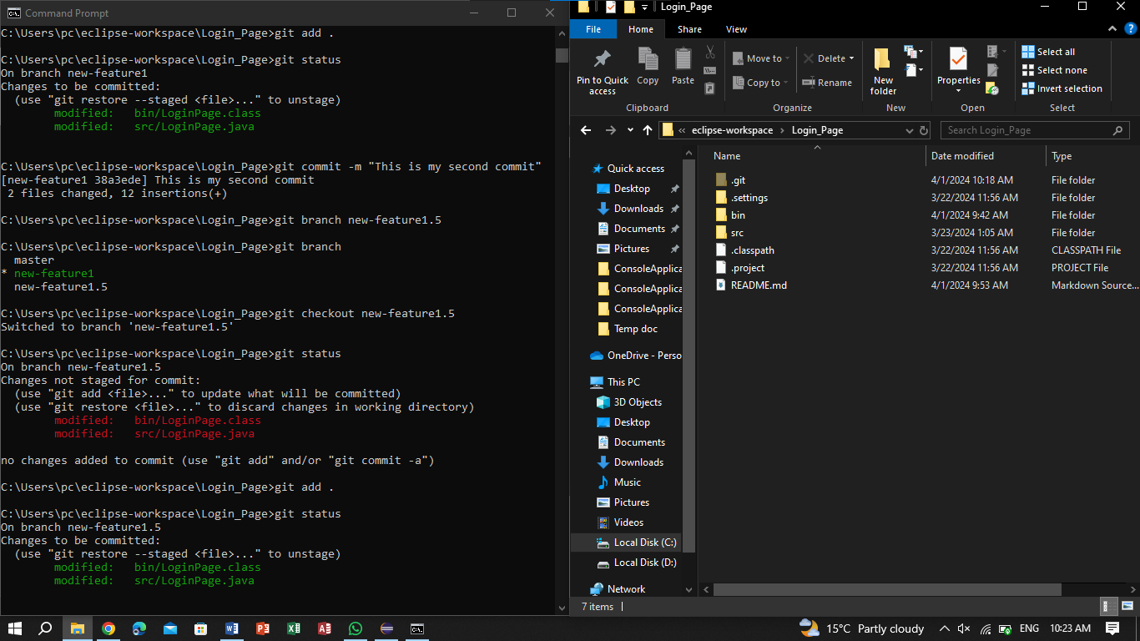

1. Setting virtual repository

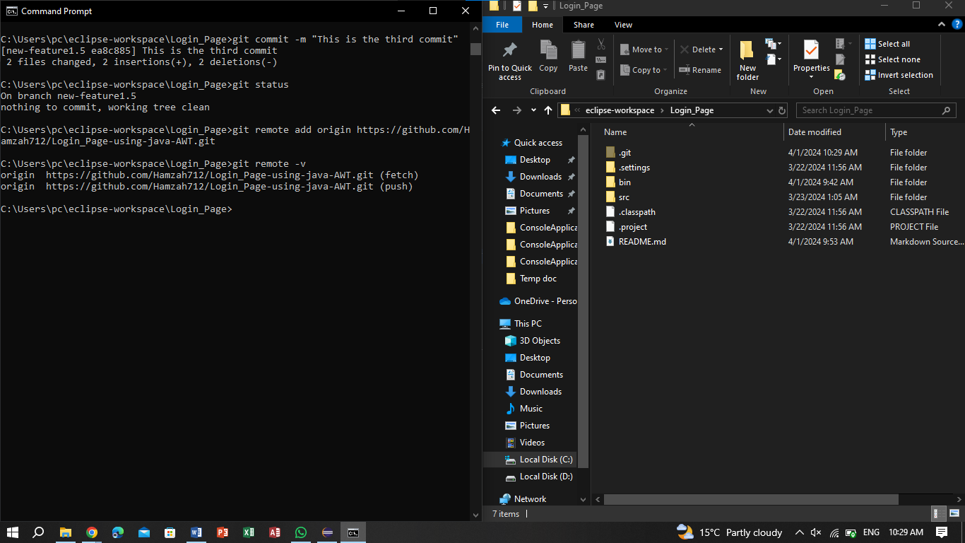

1. Pushed master branch to remote origin

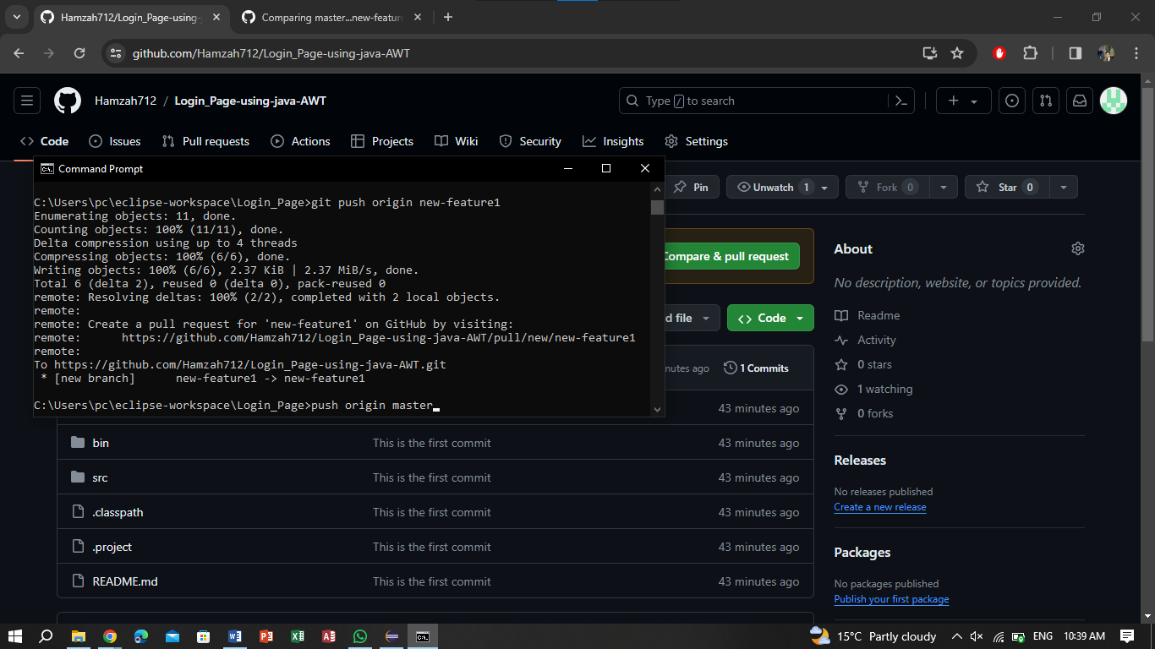

1. Push new-feature1 and create pull request

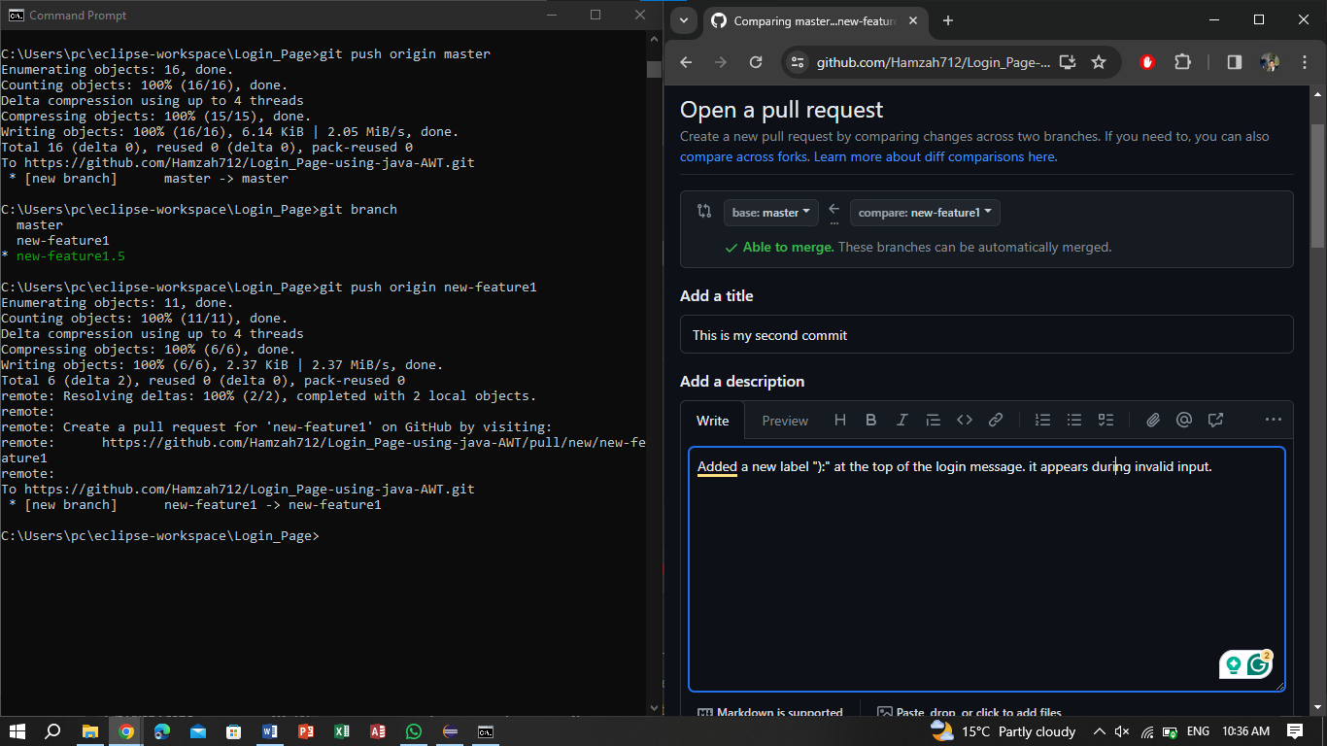

1. Merge pull request & delete branch

